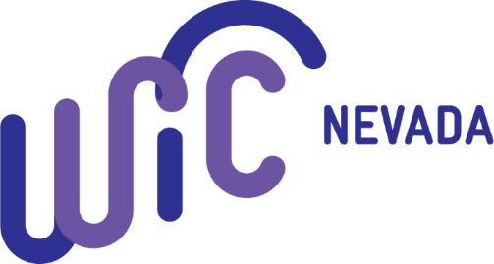

The Nevada State WIC Program would first like to express great gratitude toward grocery store staff through the COVID-19 pandemic. Grocery stores have been on the frontlines throughout this crisis, allowing our population to still able to feed themselves and their families during these scary and uncertain times. We know that extra restrictions and work to ensure the safety of customers and staff have been put on your stores, so we understand how limited staff time can be. Your work and dedication during this time has not gone unnoticed or unappreciated!
As our state continues fight the spread of this virus and protect those most vulnerable, the Nevada WIC Program was provided funding through the Coronavirus Aid, Relief and Economic Security Act (CARES) to start the WIC grocery delivery program. This is a short-term program (ends 12/31/2020) that will assist in need WIC Participants redeem their WIC benefits.
Nevada WIC is partnering with nonprofit agencies across the state whose staff will conduct WIC Shopping and delivery for at risk participants and their families. Training on WIC Shopping has been provided to these shoppers and will be on going as necessary.
Knowing that shopping for WIC foods can be difficult at first, Nevada WIC is asking our vendor partners to assist these shoppers when making purchases for the in-need families. One way that stores can help shoppers is by labeling WIC foods with the yellow WIC APPROVED shelf tags. If you need shelf tags please send an email to wicgeneral@health.nv.gov or call the main WIC line at 775-684-5942 or 800-863-8942. Any technical assistance that can be provided at check out would also be very valuable to this program.
Staff from these agencies who conduct the shopping may be making WIC purchases for multiple families at one time. If shopping for more than one WIC family, shoppers have been instructed to separate items and transactions must be completed separately. As part of program integrity these shoppers will have a letter from the State WIC Office identifying them as a shopper for the program.
As we know, WIC transactions can take some time, especially as these shoppers may be making multiple transactions. The WIC state office is asking stores to provide as much assistance to these shoppers as they can. This shopping program made available through the short-term CARES funding, is a unique way that Nevada is able to ensure our at risk Mom’s and young families do not go without the food/formula’s they need to grow healthy families.

