**October/National WIC Enrollment Week 2024 Social Media Messaging - English**

*The following visuals and copy can be used by WIC staff for any outreach purposes, including posting to social media pages. Feel free to edit the copy and website or contact information to make it specific to your clinic. Hashtags and suggested posting dates are optional, observance day posts can be shared anytime by editing the suggested captions to fit your clinic’s needs.*

***You can download high-resolution versions of the graphics*** [here](https://nyc3.digitaloceanspaces.com/wicshare/2024/09/English_October-National-WIC-Enrollment-Week-2024-Graphics.zip)***.*** *Please reach out to us at* [*campaign@nwica.org*](mailto:campaign@nwica.org) *if you have any questions!*

**1. Dads Are Welcome at WIC**

Dads, you can be involved in WIC too! From healthy foods and nutrition education to healthcare referrals and peer support, WIC has many ways to help you support your family! 👨‍🍼👨🏻‍🍼👨🏾‍🍼

Learn more about WIC and contact your local WIC clinic at [www.signupwic.com](http://www.signupwic.com).

#HealthyStartsHere #StartWithWIC #Dads

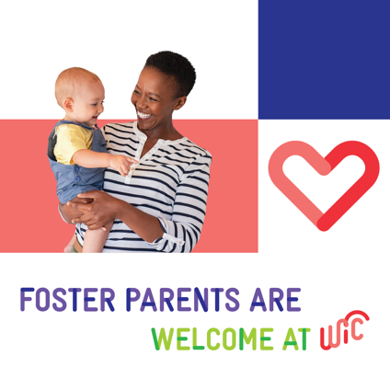**2. Foster Parents Are Welcome at WIC**

Foster parents, did you know foster children under the age of five automatically qualify for WIC benefits? Many families believe enrolling in WIC might take resources away from other families but that’s not the case. There is no limit to the number of families who can receive WIC benefits!

Learn how WIC can support your family at [www.signupwic.com](http://www.signupwic.com).

#HealthyStartsHere #StartWithWIC #FosterParents

**3. Grandparents Are Welcome at WIC**

As a grandparent or other caregiver raising children whose parents cannot, you can apply for WIC benefits for children up to age 5 in your care!

Through WIC, you can access healthy foods, nutrition counseling, healthcare referrals, and other support for your family. Learn more and find a WIC clinic near you at [www.signupwic.com](http://www.signupwic.com)

#HealthyStartsHere #StartWithWIC #Grandparents

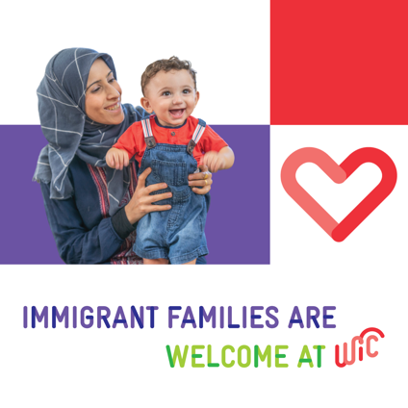**4. Immigrant Families Are Welcome at WIC**

If you moved to the United States, you can still get help from WIC! Signing up for WIC won’t affect your immigration status or ability to become a U.S. citizen or permanent resident.

If you are recently pregnant, breastfeeding, or caring for a child under 5—you can get nutritious food, breastfeeding and prenatal support, healthcare referrals, and more from WIC. ✨

Learn more about WIC and how to enroll at [www.signupwic.com](http://www.signupwic.com)

#HealthyStartsHere #StartWithWIC #ImmigrantFamilies

**5. Military Families Are Welcome at WIC**

Did you know 🤔 Basic Allowance for Housing (BAH) and Overseas Cost of Living Allowance (COLA) are not counted when applying for WIC? Plus, many WIC offices are located on or near military bases, making it even easier to get your family the food and resources you need! 👏

WIC is also available for service members overseas, so even if you didn’t qualify for WIC benefits before, you might when moving internationally or OCONUS.

You can enroll in WIC at any time, including during National WIC Enrollment Week (October 7-11)! Visit [www.signupwic.com](http://www.signupwic.com) for more information.

#HealthyStartsHere #StartWithWIC #MilitaryFamilies

**6. Celebrate National WIC Enrollment Week with Instagram Live**

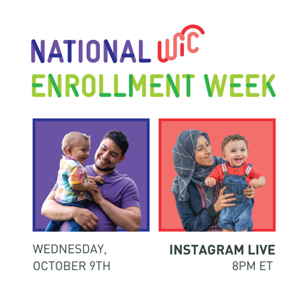🌟 Want to learn how WIC can support your family? 🌟 Join @WICYouGotThis on Wednesday, October 9, at 8 PM ET for an Instagram Live all about WIC! We'll be diving into everything you need to know about the program, its benefits, and how it can help your family thrive. 💪👨‍👩‍👧‍👦

Set a reminder, think of some questions, and get ready to learn about WIC!

📅 Date: Wednesday, October 9

⏰ Time: 8 PM ET

📍 Where: @WICYouGotThis on Instagram

WIC is a supplemental nutrition program for those who are recently pregnant, breastfeeding, or caring for a child under 5. Visit [www.signupwic.com](http://www.signupwic.com) to learn more or find a WIC clinic near you.

#HealthyStartsHere #StartWithWIC #IGLive

**7. Pregnancy Benefits**

You don’t have to wait until you have your baby to apply for WIC—you can enroll as soon as you know you’re pregnant! 🤰🏻🤰🏽🤰🏿 Whether you’re expecting, have a baby, or have little ones under age 5, WIC is here for YOU!

We offer prenatal nutrition, healthcare referrals, peer support, breastfeeding education, and more. Get started on your WIC journey this National WIC Enrollment Week October 7–11 and anytime throughout the year by visiting [www.signupwic.com](http://www.signupwic.com) ✨

#HealthyStartsHere #StartWithWIC #Pregnancy

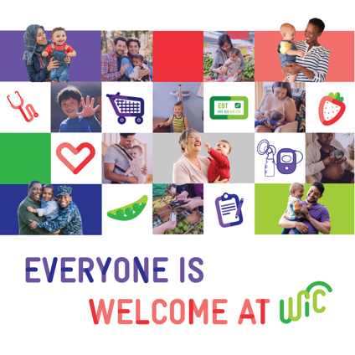**8. Everyone is Welcome at WIC**

WIC is here for moms, dads, parents, grandparents, foster parents, aunts, uncles, and guardians of all kinds! If you are pregnant, breastfeeding, or caring for a child under 5—you can get nutritious food, breastfeeding

support, health referrals, and more from WIC. ✨

You can enroll in WIC at any time, including during National WIC Enrollment Week (October 7-11)! Visit [www.signupwic.com](http://www.signupwic.com) for more information.

#HealthyStartsHere #StartWithWIC

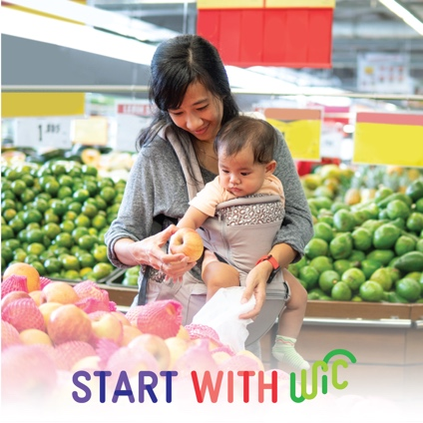**9. WIC Benefits**

✔️ Breastfeeding and prenatal support

✔️ Healthy foods and nutrition education

✔️ Health and social service referrals

✔️ Peer support and more!

If you are recently pregnant, breastfeeding, or caring for a child under 5, you can receive WIC benefits. Enroll in WIC during National WIC Enrollment Week October 7-11 or anytime throughout the year! Contact your local agency to sign up or learn more: [www.signupwic.com](http://www.signupwic.com)

#HealthyStartsHere #StartWithWIC

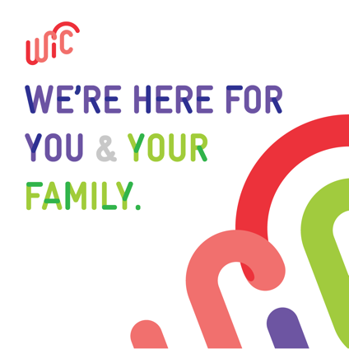**10. General WIC**

WIC has so much to offer your family 💓 From healthy food and nutrition education to mental health referrals and breastfeeding support, WIC can help you take care of yourself and your family.

National WIC Enrollment Week (October 7-11) is the perfect time to apply for WIC! Whether you have a baby, are recently pregnant, breastfeeding, or have little ones under age 5, you can apply! 🌟 Learn more and contact your local clinic at [www.signupwic.com](http://www.signupwic.com)

#HealthyStartsHere #StartWithWIC

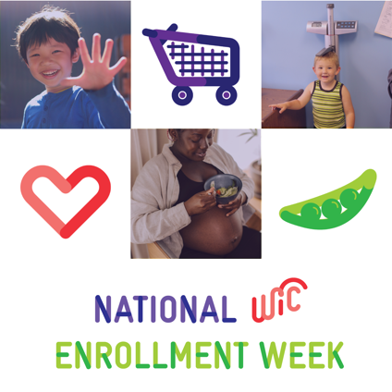**11. National WIC Enrollment Week**

🎉 Happy National WIC Enrollment Week! 🎉 From October 7-11, discover the amazing benefits WIC offers families, from nutritious foods to valuable support.

Ready to apply or re-enroll? Now’s the perfect time! Visit [www.signupwic.com](http://www.signupwic.com) or contact your local agency to get started. 🌟

#HealthyStartsHere #StartWithWIC

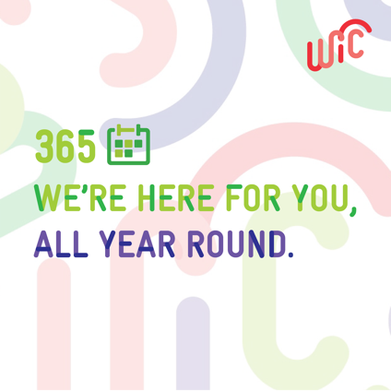**12. End of National WIC Enrollment Week**

🌟 It’s the last day of National WIC Enrollment Week, but you can apply for WIC all year long! 🌟If you are recently pregnant, breastfeeding, or caring for children under age 5, you may qualify for WIC! Learn more about WIC and start the enrollment process at [www.signupwic.com](http://www.signupwic.com).

#HealthyStartsHere #StartWithWIC