September 2024 Social Media Messaging - English
The following visuals and copy can be used by WIC staff for any outreach purposes, including posting to social media pages. Feel free to edit the copy and website or contact information to make it specific to your clinic.
Hashtags and suggested posting dates are optional, observance day posts can be shared anytime by editing the suggested captions to fit your clinic’s needs.
You can download high-resolution versions of the graphics here. Please reach out to us at campaign@nwica.org if you have any questions!
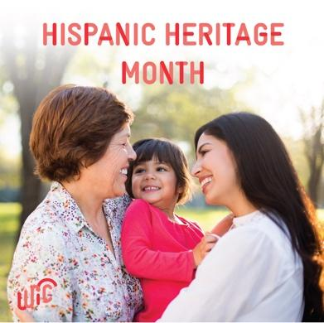
1. Hispanic Heritage Month: September 15 – October 15
#HispanicHeritageMonth is a month-long celebration of Hispanic and Latino history and culture, from September 15 – October 15. 💖
At WIC, we celebrate Hispanic and Latino families by working to uplift their traditions through culturally specific resources and support for breastfeeding, meal preparation/recipes, and more.
Find a clinic near you to learn more about WIC by visiting www.signupwic.com! #HealthyStartsHere

2. Baby Safety Month
It’s #BabySafetyMonth, we’re highlighting safe-sleep practices you can use all year long! 👶
Safe Sleep Quick Tip: Before putting your baby down to sleep, remember a firm, flat mattress and fitted sheet are all you need for your baby’s crib. Blankets and toys can be hazards, so remove them from the crib, and use a sleep sack on colder nights.
Learn more about safe-sleep environments and how to protect your baby while they rest. https://safetosleep.nichd.nih.gov/reduce-risk/safe-sleep-environment
#BabySafety #SafeSleep #WIC #HealthyStartsHere

3. Whole Grain Month
September is #WholeGrainMonth! Did you know a wide variety of whole-grain foods are #WICApproved? This includes pasta, bread, cereal, rice, oats, and more! 🙌
Check out these kid friendly whole-grain recipes that are delicious and nutritious for the whole family including whole grain pancakes 🥞with fresh berries and yogurt: https://www.health.state.mn.us/people/wic/recipes/breads.html
#WholeGrains #WICRecipes #HealthyStartsHere

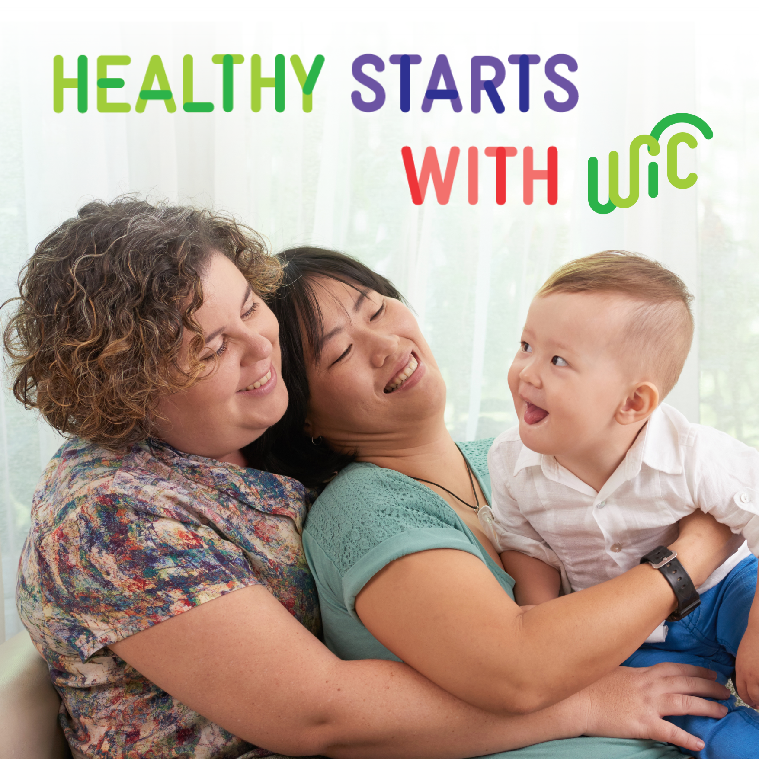
4. National Family Day - September 23
Today is National Family Day, a day for us to gather around the table and enjoy a meal together! 🍽️
What are your family’s favorite foods to make together? Write down your favorite recipes or create a family recipe book to have on hand for future meals together! 👩‍🍳
Don’t forget your WIC benefits when grocery shopping! Start the enrollment process at www.signupwic.com
#NationalFamilyDay #FamilyDinner #ToddlerFriendlyRecipes #BabyFriendlyRecipes #HealthyStartsHere
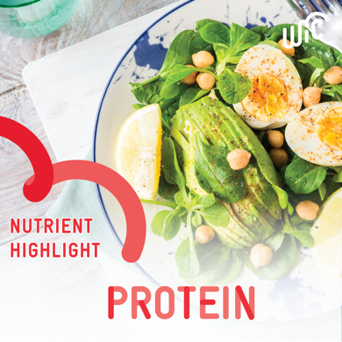
5. Nutrient of the Month: Protein
Protein is important for breastfeeding parents and their babies! It helps you produce milk, maintain your muscles, and gives your baby the nutrition they need. Plus, it supports your little one’s growth and immune system development. 🐟🫘🧀
Help meet your protein goals with WIC! WIC-approved sources of protein include:
🌟 Tinned fish (tuna, sardines, salmon)
🌟 Eggs and Dairy Products
🌟 Beans and Tofu

Not on WIC yet? Get more information and find a clinic near you at www.signupwic.com.
#HealthyStartsHere #BreastMilk #BreastFedBaby #Lactation
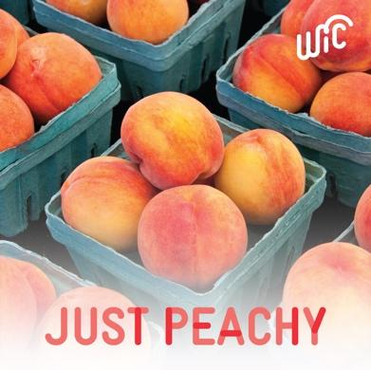
6. WIC-Approved Food of the Month: Peaches
Peaches are this month’s #WICApproved food of the month! 🍑
Not only are peaches in-season at many farmers markets this summer, but they’re also loaded with vitamin A, vitamin C, and potassium to keep you and your little ones healthy—and we think that’s just peachy.
Visit www.signupwic.com to find a clinic near you! 🌟
#HealthyStartsHere #FarmersMarket #FreshProduce
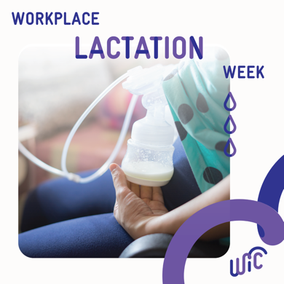
7. Workplace Lactation Week (September 1-7)
It's Workplace Lactation Week! This year's theme, “Policy to Practice: Making Lactation Support a Reality,” celebrates the significant strides made to support breastfeeding parents. With three major federal laws—the PUMP Act, Pregnant Workers Fairness Act, and updated Title IX Regulations—now in place, we're creating safer and more supportive environments for nursing workers and students.
Learn more about your breastfeeding rights: https://www.dol.gov/sites/dolgov/files/WHD/flsa/WHD_EEOC_FINAL.pdf.
WIC supports lactation in the workplace by providing breast pumps, peer counselors, IBCLCs and other types of support to program participants. Get breastfeeding support from #WIC by finding a local clinic near you at www.signupwic.com.
#HealthyStartsHere #BreastMilk #BreastFedBaby #Lactation

8. Semana de La Lactancia Latina (September 5-11)
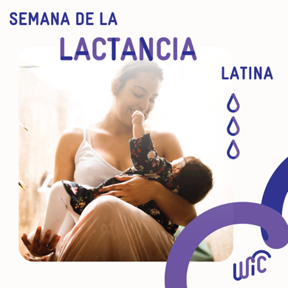
This week marks the annual #SemanaDeLaLactanciaLatina, and WIC is proud to support Latina breastfeeding parents across the US with food packages specific to breastfeeding parents, peer support, breastfeeding counseling, and more! This year’s theme is Reclamando Nuestra Cultura Por Medio de la Lactancia. 💖
Get breastfeeding support from #WIC and find a local clinic near you at www.signupwic.com.
#HealthyStartsHere #BreastMilk #BreastFedBaby #Lactation
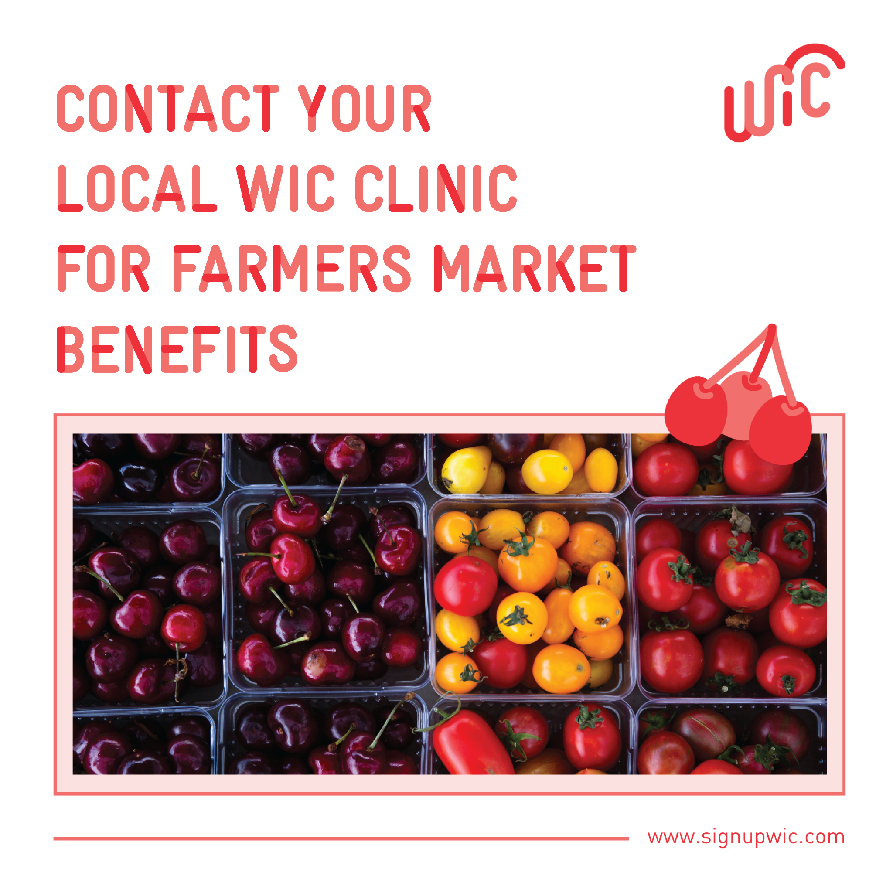
9. Farmers Market Nutrition Program
It’s farmers market season, y’all! 🍒 Don't forget to check in with your local WIC clinic to receive your benefits (checks or EBT card) and use them on fresh, locally grown produce at the farmers market. Remember, these are in addition to your regular monthly #WIC benefits! 🙌
Haven’t signed up for WIC yet? Visit www.signupwic.com to get started!
#HealthyStartsHere #FarmersMarket #FreshProduce

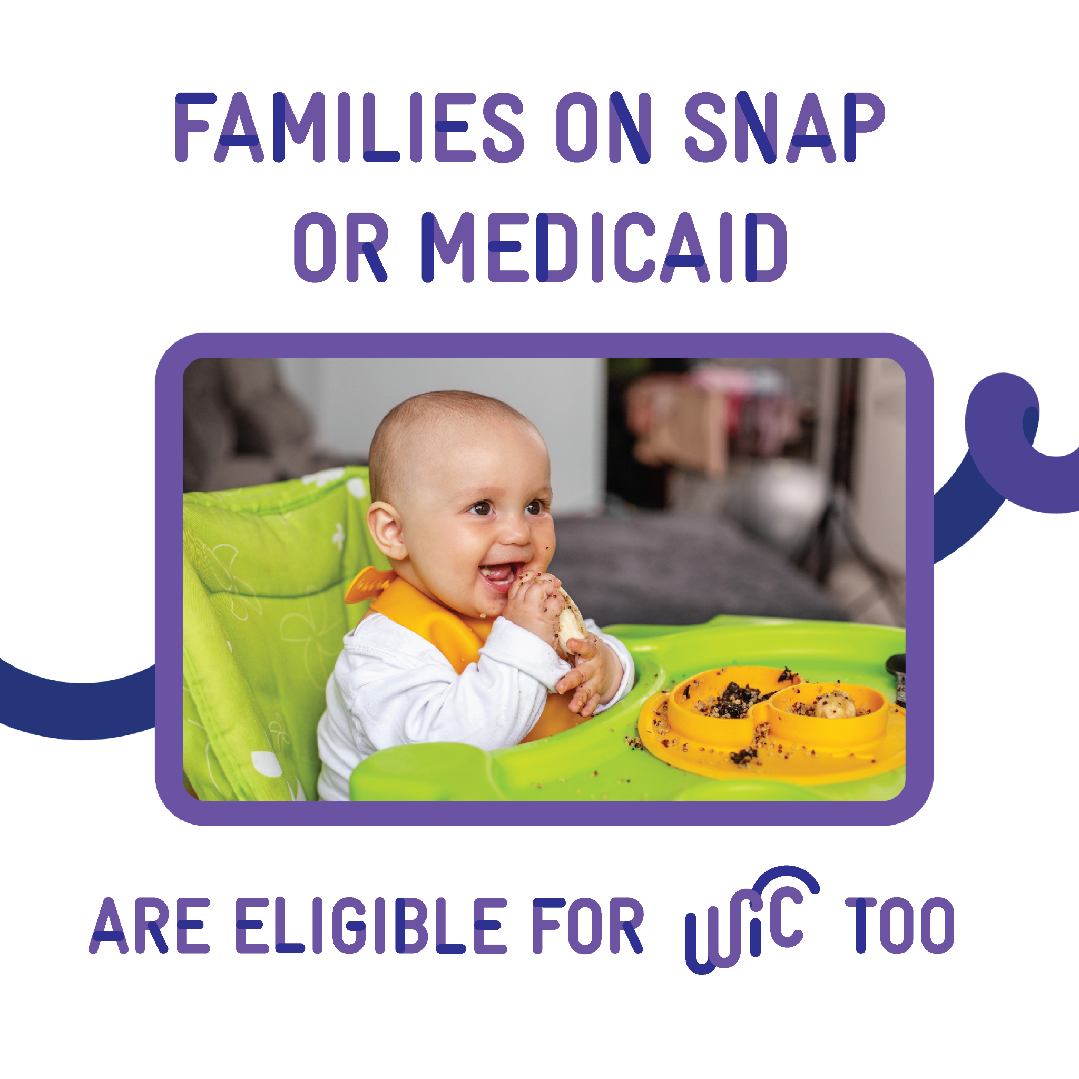
10. Medicaid + SNAP Eligibility
Did you know families who are enrolled in Medicaid and SNAP are automatically eligible for WIC? 🤔
Don’t wait to get started! 🥑🍞 🍳 Learn more and discover a WIC clinic near you by visiting www.signupwic.com.
#HealthyStartsHere #Medicaid #SNAP

11. Taste-Test Night
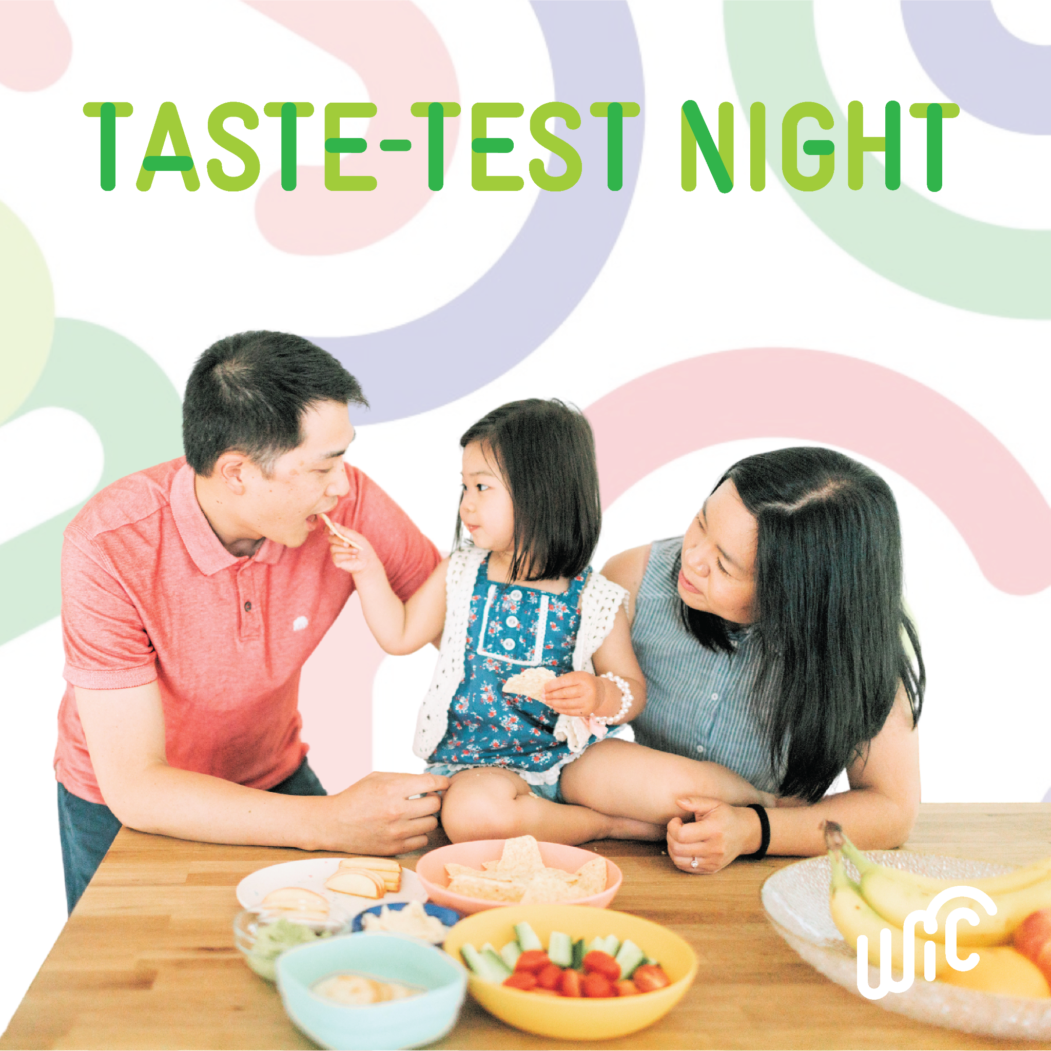
Host a "taste test" night where your family can try different fruits and veggies together and vote on favorites. 🍅🥒 This can encourage babies and toddlers to try new foods. And you get the bonus of spending some quality time together!
What would you sample with your little ones on a taste test night? Visit www.signupwic.com to learn more about WIC!
#WIC #HealthyStartsHere #FamilyTime #ToddlerFriendlyRecipes #BabyFriendlyRecipes

12. Plugged Ducts
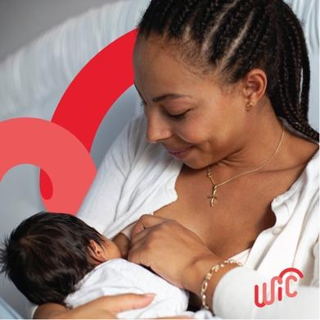
Plugged milk ducts can happen when a milk duct does not drain properly. Although it can be uncomfortable, it is common, and there are a few things you can try to get relief! 👶
🌟 Lightly massage your breast from the plugged duct down to the nipple before and during breastfeeding.
🌟 Apply ice or cold packs.
🌟 Breastfeed on demand and use different positions.
🌟 Empty the affected breast first.
If you have plugged ducts or any questions about breastfeeding, reach out to a WIC breastfeeding expert for support. Visit www.signupwic.com to find a WIC clinic near you!
#HealthyStartsHere #BreastFedBaby #Breastfeeding #Lactation #LactationSupport

