**November 2024 Social Media Toolkit - English**

*The following visuals and copy can be used by WIC staff for any outreach purposes, including posting to social media pages. Feel free to edit the copy and website or contact information to make it specific to your clinic.*

*Hashtags and suggested posting dates are optional, observance day posts can be shared anytime by editing the suggested captions to fit your clinic’s needs.*

***You can download high-resolution versions of the graphics and short video*** [***here***](https://wicshare.nyc3.digitaloceanspaces.com/2024/10/31183753/November-Toolkit-Graphics-and-Video.zip)***.*** *Please reach out to us at* [*campaign@nwica.org*](mailto:campaign@nwica.org) *if you have any questions!*

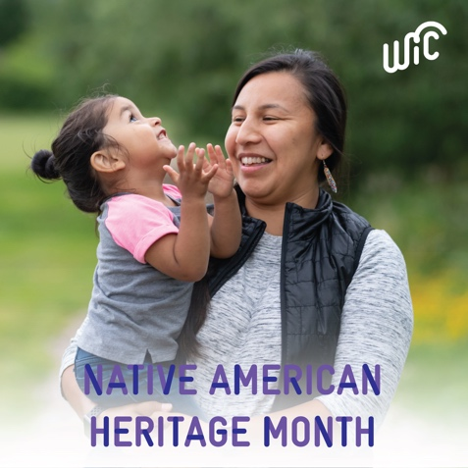

1. **Native American Heritage Month**

This November, we honor Native American Heritage Month—a time dedicated to acknowledging the history, honoring the traditions, and celebrating the contributions of Indigenous and Native American people.

At WIC, we strive to make every family feel heard, seen, valued, and supported. We’re committed to supporting families with nutritious foods and culturally relevant resources that honor traditional practices and strengthen our communities. 🧡

Learn more about WIC and find a clinic near you at [www.signupwic.com](http://www.signupwic.com).

#HealthyStartsHere #NativeAmericanHeritageMonth

1. **Gratitude/Thanksgiving**

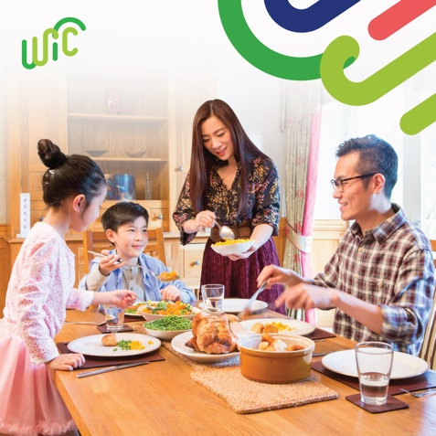At WIC, we are reminded every day of the strength, resilience, and love within the families we serve. Today, we express our gratitude to the parents and caregivers who work tirelessly to provide for their little ones. Your dedication to their health and well-being inspires us!

We’re thankful for the opportunity to support you on your journey, and we’re committed to helping you nurture your families through healthy foods, nutrition education, breastfeeding support, and more. Together, we are creating brighter and healthier futures. 🩵

Thank you for allowing us to be a part of your story.

#HealthyStartsHere

1. **Bison and Wild Rice Soup Recipe - National Bison Day is Nov. 4**

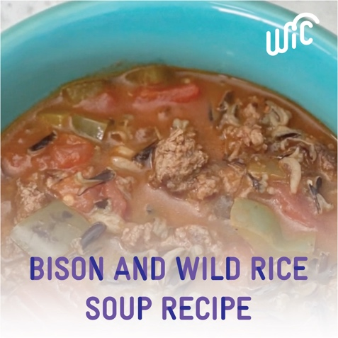Warm up with this delicious soup featuring nutritious ingredients like bison, wild rice, and veggies—a beautiful tribute to traditional Indigenous foods that have nourished families for generations. This recipe is packed with protein, fiber, and flavor, making it a perfect choice for family gatherings or a comforting meal at home. 🍲

Special thanks to the Otoe-Missouri Tribe WIC of Oklahoma for this recipe!

Find the recipe here: <https://www.omtribe.org/wp-content/uploads/Bison-Wild-Rice-OM.pdf>

#WICrecipes #HealthyStartsHere #NativeAmericanHeritageMonth

1. **Children’s Day - Post on Nov. 20**

At WIC, we believe every child deserves the best start in life. On World Children’s Day, we celebrate the incredible potential of every little one. 💙

WIC helps families get what they need, from healthy foods to breastfeeding support. If you are recently pregnant, breastfeeding, or caring for a child under 5, you may qualify for WIC!

Learn more about WIC at [www.signupwic.com](http://www.signupwic.com).

#HealthyStartsHere #WorldChildrensDay #ForEveryChild

1. **Farmer’s Market Nutrition Program**

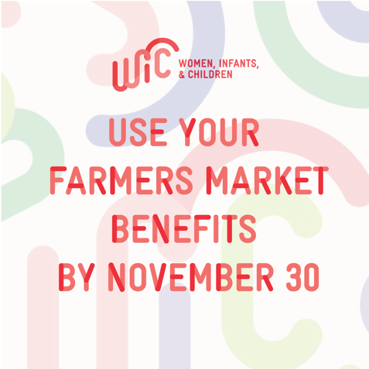

Reminder: Use your WIC Farmers Market Nutrition Benefits by November 30! 🥕🥦🍎

If you have questions, contact WIC for more information about your FMNP benefits. WIC can also help you find your local farmers markets!

Visit [www.signipwic.com](http://www.signipwic.com) to find a WIC clinic near you.

#HealthyStartsHere #FarmersMarket

1. 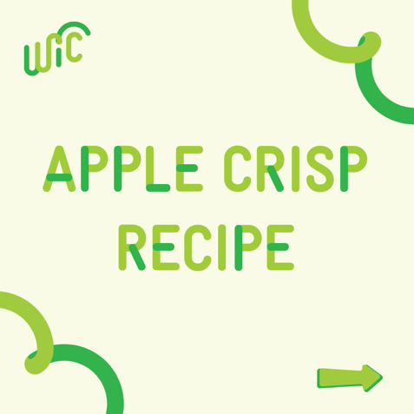**Apple Crisp Recipe - this post includes multiple images (all labeled by which order they go in)**

Who’s ready to embrace all the warm and cozy fall vibes? With baked apples and a cinnamon, brown sugar oat topping, apple crisp is the perfect treat for chilly autumn days. 🍏 It’s simple to make, smells incredible, and tastes even better! 😋

For more delicious and nutritious recipes, connect with your local WIC clinic! Learn more at [www.signupwic.com](http://www.signupwic.com).

#HealthyStartsHere #WICrecipes

1. **In-Season Fruits & Veggies**

Fall is the perfect time to enjoy flavorful and nutritious in-season fruits and veggies! Autumn offers a wide variety of produce perfect for your family meals:

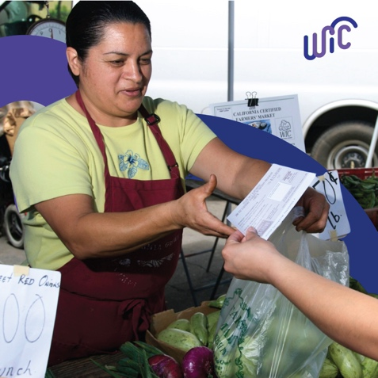

🍏 Apples

🥔 Sweet Potatoes

🍠 Squash

🥕 Carrots

🥦 Broccoli

🍇 Grapes

🥬 Kale

🍐 Pears

Eating seasonal produce isn’t just delicious—it’s usually more affordable, too! Use your WIC benefits to pick up your family's favorites, and find recipes on your WIC app.

Learn more about WIC and find your local clinic at [www.signupwic.com](http://www.signupwic.com).

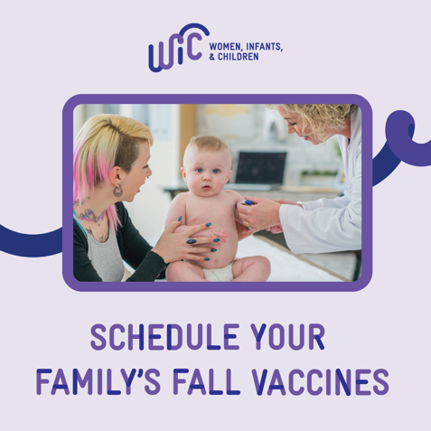#HealthyStartsHere

1. **Fall Vaccines**

As cooler weather arrives, so does cold and flu season. From flu shots to COVID-19 boosters, vaccines prevent serious illnesses and are one of the best ways to keep you and your little ones safe and healthy. And WIC can help! 💖

Learn more and find your local clinic at [www.signupwic.com](http://www.signupwic.com/).

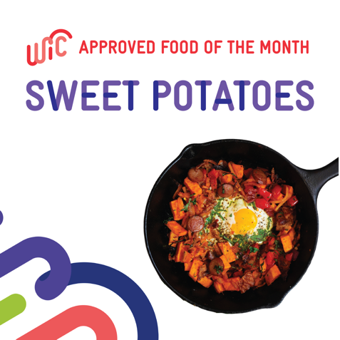#VaccinesWork #HealthyStartsHere

1. **Food Spotlight: Sweet Potato**

Packed with flavor, fiber, and nutrients like Vitamin A and potassium, sweet potatoes are a delicious and healthy addition to your meals! Whether baked, mashed, or roasted, sweet potatoes are easy to add to any meal—and kids love their naturally sweet taste! 🍠

Find sweet potato recipes and more: <https://snaped.fns.usda.gov/resources/nutrition-education-materials/seasonal-produce-guide/sweet-potatoes-yams>

#HealthyStartsHere

1. **Nutrient Highlight: B Vitamins**

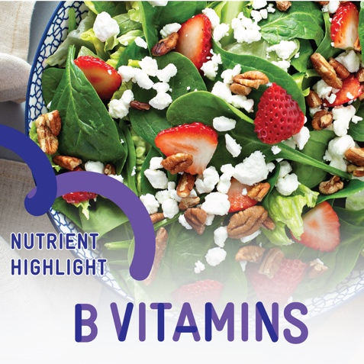B vitamins are essential for keeping your body energized and healthy! Each B vitamin plays a role, supporting everything from energy levels to brain function. 🥗 Here’s why they matter:

* B1 (Thiamine): Helps your body turn food into energy and supports nerve function.
* B2 (Riboflavin): Important for vision and skin health and red blood cell production.
* B6: Supports brain development and helps the body make serotonin, which regulates mood.
* B9 (Folate): Critical during pregnancy for healthy fetal development and supports cell growth.
* B12: Vital for red blood cell formation and maintaining a healthy nervous system.

You can find B vitamins in whole grains, eggs, leafy greens, and lean meats. Eating a balanced diet ensures you and your family get all the nutrients your bodies need to thrive!

Did you know your family could receive food benefits and nutrition education through WIC? Find out more at [www.signupwic.com](http://www.signupwic.com).

#HealthyStartsHere

1. **Fall Family Activities**

As the leaves change and the air gets crisp, families have many options for fun activities! Try out these some kid friendly ideas with your family:

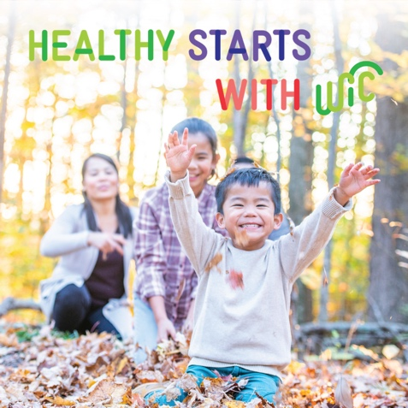🎃 Pumpkin Decorating: Get creative with your pumpkins! Check out these no-carve pumpkin decorating ideas: <https://bit.ly/40qKZgK>

🍂 Nature Walks: Explore your local parks and enjoy the beautiful fall colors. It’s a great way to stay active and bond as a family, plus, it’s good for your health! Learn more about why outdoor play is important for kids: <https://bit.ly/4f2KTA1>

🍲Healthy Harvest Cooking: Use seasonal produce to cook delicious meals together and pick out new recipes to try as a family! Find fall recipes here: <https://bit.ly/3YHVJWp>

#HealthyStartsHere

1. **Video - Fall Family Activities (**[**Downloadable Video in this Folder**](https://wicshare.nyc3.digitaloceanspaces.com/2024/10/31183753/November-Toolkit-Graphics-and-Video.zip)**)**

Celebrate fall with these fun, family activities! 🍂 🎃

#HealthyStartsHere