ENGLISH TEXT
Image | Text
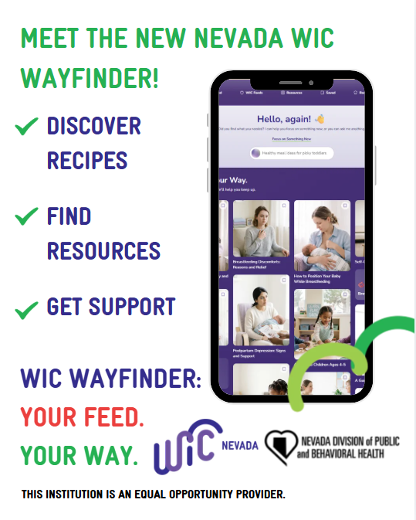 | The new Nevada WIC Wayfinder website is here to help you find the information you need when you need it. Discover WIC foods, find new recipes and resources. Visit the WIC Wayfinder at https://hub.nevadawic.org today!  For more information on the Nevada WIC Program, call 1-800-863-8942 or visit https://nevadawic.org/.
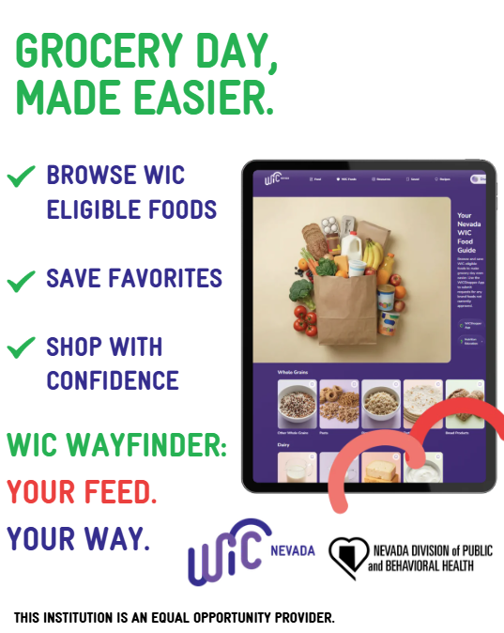 | Unsure what foods are WIC approved? The new Nevada WIC Wayfinder website is here to help you find WIC foods when you are on the go. Visit the WIC Wayfinder at https://hub.nevadawic.org to see what is authorized and what is not.  For more information on the Nevada WIC Program, call 1-800-863-8942 or visit https://nevadawic.org/.
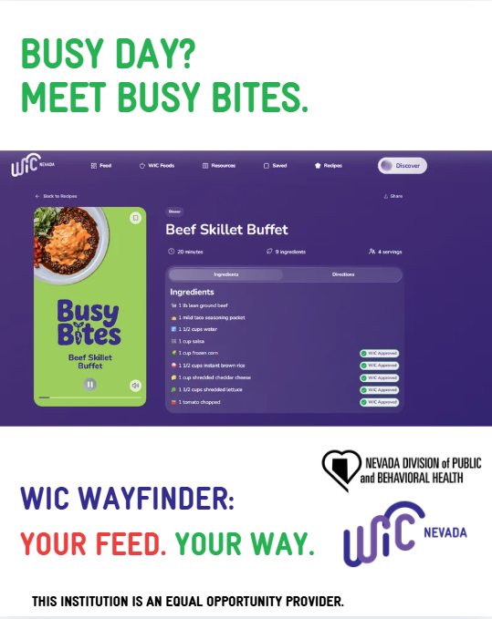 | Busy day? The new Nevada WIC Wayfinder website has recipes for you! Busy Bites were designed with your family in mind. Offering quick recipe videos with WIC foods, Busy Bites is here for you. Visit the WIC Wayfinder at https://hub.nevadawic.org to see what quick meals you can whip up with WIC!  For more information on the Nevada WIC Program, call 1-800-863-8942 or visit https://nevadawic.org/.
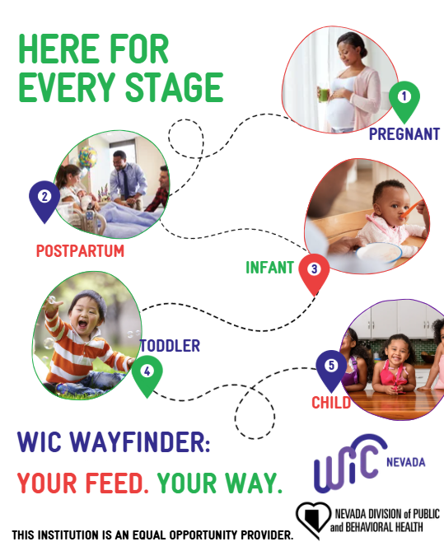 | The new Nevada WIC Wayfinder website has something for you, no matter what stage you are in. Whether you are pregnant and feeding a toddler, or nearly postpartum, the Wayfinder has information for you! Visit the WIC Wayfinder at https://hub.nevadawic.org to find the information you need when you need it!  For more information on the Nevada WIC Program, call 1-800-863-8942 or visit https://nevadawic.org/.
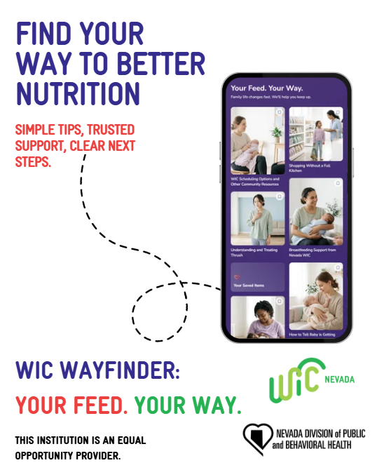 | The new Nevada WIC Wayfinder website is here to help you find your way to better nutrition. Discover new WIC foods, recipes and resources. Visit the WIC Wayfinder at https://hub.nevadawic.org today!  For more information on the Nevada WIC Program, call 1-800-863-8942 or visit https://nevadawic.org/.
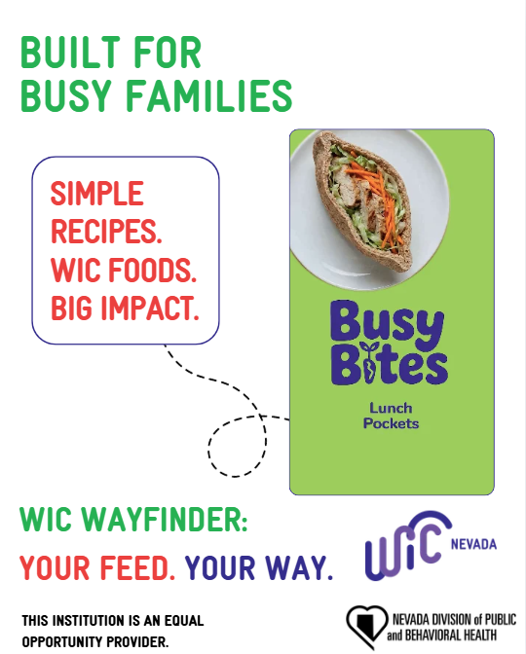 | Busy day? The new Nevada WIC Wayfinder website has recipes for you! Busy Bites were designed with your family in mind. Offering simple recipes and videos made with WIC foods, Busy Bites is here to help you make a big impact. Visit the WIC Wayfinder at https://hub.nevadawic.org to see what quick meals you can whip up with WIC!  For more information on the Nevada WIC Program, call 1-800-863-8942 or visit https://nevadawic.org/.

